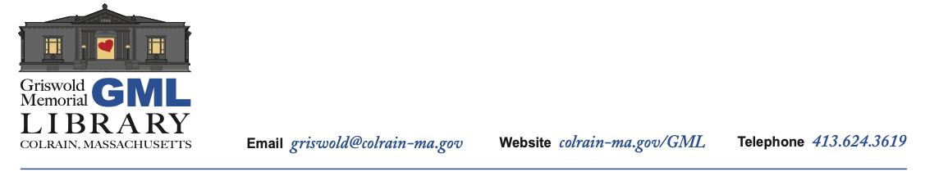

**GML Board of Trustees Policy Committee Meeting Agenda**

March 22, 2021, 1pm, Conference call

Conference call dial number: (701) 802-5415

Access code: 288711

Review Library bylaws

*Other Items Not Anticipated by the Chair 48 Hours Prior to Meeting May be Added*