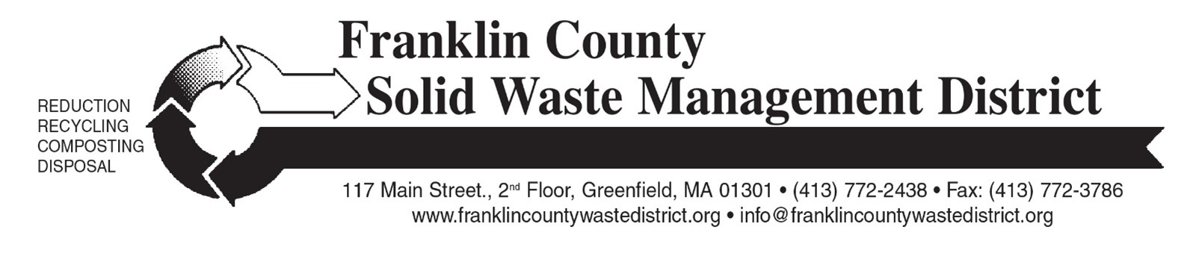
Press Release: for Immediate Release

To: Greenfield Recorder, West County Shopper
From: Amy Donovan, amy@franklincountywastedistrict.org
Re: New food and paper waste compost program at the Colrain Transfer Station

Image captions: “Compost dumpster at a Franklin County Transfer Station.”
“Earth Machine home compost bin”

New Food and Paper Waste Compost Program at the

Colrain Transfer Station

On May 30th, a new food and paper waste compost program will begin at the Colrain Transfer Station on Charlemont Rd. The collection is open to Colrain residents only, during transfer station open hours. There is no cost to participate in this program.
Similar compost programs are successful at 14 municipal transfer stations in the county: Bernardston, Charlemont, Conway, Deerfield, Greenfield, Leverett, Montague, New Salem, Northfield, Orange, Shelburne, Warwick, Wendell, and Whately. Franklin County is a statewide leader in school and transfer station compost programs.

Why compost?
Composting makes a valuable soil amendment from waste, reduces trash, saves money, and slows climate change. Households that separate their food waste for composting can potentially reduce their trash volume and save money on required town trash stickers.

From Colrain Transfer Station to Martin’s Farm
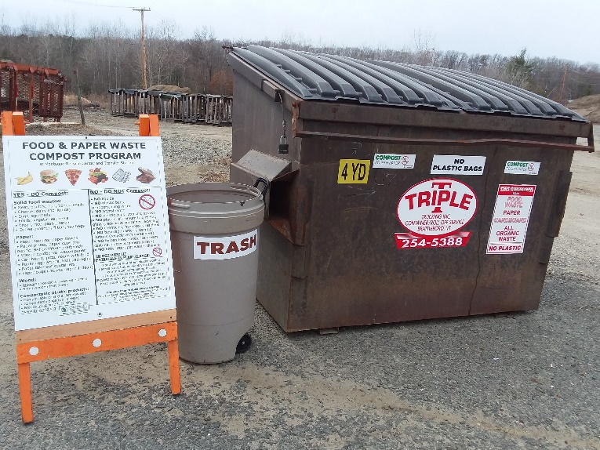
Triple T Trucking will place a special compost dumpster at the transfer station. The container will be emptied weekly, and the contents brought to Martin’s Farm in Greenfield for composting. This commercial composting facility is different from your average backyard compost system in that it can compost meat, bones, cheese, paper products, and other materials that are not appropriate for home compost bins or piles.
The new compost program will accept many materials that are currently destined to go in the trash. All solid food wastes are acceptable including meat, bones, poultry, fish, cheese, dairy (no liquids), eggs, eggshells, shellfish, fruits, peels, vegetables, bread, grains, tea bags, coffee grounds and paper filters. Paper is also accepted: napkins and paper towels, paper egg cartons, paper to-go containers, and pizza boxes with stuck-on food. (Pizza boxes and other paper items that are empty and free of food should go in paper recycling.)
It is very important to keep the following items OUT of the compost container: liquids; pet wastes, kitty litter, diapers; plastic bags, wrappers or cling wrap; polystyrene foam; conventional plastic, metal, foil, glass; or non-biodegradable items. Yard waste, leaves and brush are not accepted in this program.

How to participate
To collect compostable items at home, residents can use a compost pail, 5-gallon bucket or any other closed container. Colrain transfer station will provide free 2-gallon “Sure-Close” kitchen food scrap collection pails for Colrain residents. To make clean-up of the pail easier, residents can line pails with newspaper, a paper bag, or a compostable BioBag. All “compostable plastic” bags and tableware must be BPI-certified; for more information, see bpiworld.org.
Colrain residents can bring their food and paper waste to the transfer station during open hours and empty their pail or container into the compost dumpster. If compostable waste is transported to the transfer station in a traditional plastic bag, the resident must empty the bag into the compost container and put the plastic bag in the trash. Plastic bags should never be put in the compost collection bin.

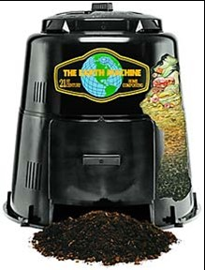
Home Compost Bins
In addition to participating in the transfer station compost program, the Solid Waste District encourages residents to also compost food waste and yard waste in home compost bins. Home composting is different from the municipal compost program at the transfer station; meat, bones, dairy and fats should not be put in home compost bins. Residents can add leaves, fruit and vegetable waste, coffee grounds, and eggshells to home compost bins to make a nutrient-rich soil amendment for home gardens.
The Town of Colrain has purchased Earth Machine compost bins to give to Colrain residents free of charge; inquire at the transfer station. The Solid Waste District sells home compost bins and pails ongoingly to residents of 21 member towns, for details, visit the district’s website at: franklincountywastedistrict.org and click on “Food Scraps & Composting.”
Residents of other towns can always purchase home compost bins from the Solid Waste District; see franklincountywastedistrict.org, or call 413-772-2438 for details.
The cost of the program, including Colrain’s home compost bins, compost collection pails, hauling and more is being funded by a Community Compact grant that the Town of Colrain was awarded from the Commonwealth of Massachusetts.
For more information, see franklincountywastedistrict.org, or contact the District office at info@franklincountywastedistrict.org or 413-772-2438. MA Relay for the hearing impaired: 711 or 1-800-439-2370 (TTY/TDD). The District is an equal opportunity provider.

